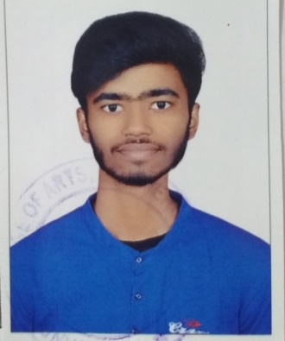

**ABHISHEK AGASKAR**

*FRONT END WEB DEVELOPER*

**Phone: +91 7208787015**

**Email:** [**agaskarabhi65@gmail.com**](mailto:agaskarabhi65@gmail.com)

**Address: Balaji Residency, Plot No. 115, Room No. 303, Sector 2, Ulwe**

Recently Graduated bachelor's degree recipient in Information Technology Specialization.  
  
“I am seeking opportunities to join a company that can help me in enhancing my skills, strengthening my knowledge and realising my potential. I am willing to explore a wide variety of opportunities that can help me gain perspective.”

**EDUCATION :**

**Mumbai University :** B.Sc IT Graduate

(2018 - 2021)

**Maharsahtra State Board :**

**HSC**  - Percentage: 52%

(2015- 2017)

**SSC**  - Percentage: 71%

(2014- 2015)

**PROJECTS:**

* **Landing Page Project :** [**https://agaskarabhi65.github.io/myproject1/**](https://agaskarabhi65.github.io/myproject1/)
* **Bootstrap Website Project:** [**https://agaskarabhi65.github.io/myproject2 /**](https://agaskarabhi65.github.io/myproject2%20/)
* **Portfolio Link: https://agaskarabhi65.github.io/portfolio/**

**WORK EXPERIENCE:**

* **Web Development:** *Fresher*
* **Other Work Experience:** *3 months work experience as an Employee at OnePointOne Solutions Private Limited, Turbhe, Navi Mumbai.*

**SKILLS:**

* HTML
* CSS
* JAVASCRIPT
* JQUERY
* BOOTSTRAP